Algebra 2 Unit 5 Notes: 5.1 Graphing Square Root Functions

Steps to Graphing and providing information
1. List transformations
2. Identify the endpoint
3. Fill out a table
4. Plot points from table onto graph paper
5. Identify Domain and Range

Identify Transformations $y=a\sqrt{b(x-h)}+k$

a = __________________________________________________________________

b = __________________________________________________________________

h = __________________________________________________________________

k = __________________________________________________________________

Identify the endpoint
This can be identified by right/left shift and up/down shift.
Example: $y=-2\sqrt{-x-3}+5$

Fill in the table and plot points on graph paper
$y=\sqrt{x}$ $y=-2\sqrt{x}$ $y=\sqrt{-\frac{1}{2}x}$ $y=\frac{1}{2}\sqrt{-3x}$

Parent Function

$x$ | $\sqrt{x}$

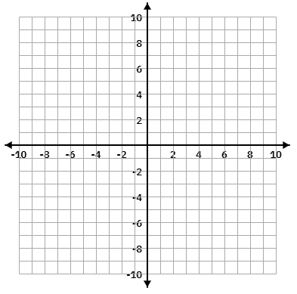
For each graph, we will list transformations, identify the endpoint, fill out a table, graph, and identify domain and range.

1. $y=2\sqrt{x}$


2. $y=\sqrt{2x}$



3. $y=-\sqrt{x-3}+4$


4. $y=\sqrt{-x+4}-1$


5. $y=-3\sqrt{-2x+8}+5$


6. $y=4\sqrt{\frac{1}{2}x+2}-3$

Write the square root equation given a point and the endpoint.

If a graph has an endpoint of (-4, -3) and contains a point (0,1), write its equation.

$y = a\sqrt{x-h}+k$ Use (x,y) and (h,k) to find a, then substitute a, h and k into the equation!

If a graph has an endpoint of (1, -5) and contains a point (2,-8), write its equation.

Given the graph, write the equation.
